Simple Queue Service

Simple Queue Service :
Amazon SQS is a fully managed message queuing service that enables decoupling and scaling of distributed systems and microservices.
Think of it like a message inbox:
- One service drops a message into the queue.
- Another service picks it up later and processes it.
- They don’t need to know about each other or be online at the same time.
Example :
Think of Amazon SQS like an order board in a restaurant:
- The waiter takes customer orders and pins them to the board → (this is the producer sending messages to SQS)
- The chef looks at the board, picks up orders, and cooks them → (this is the consumer processing messages)
- If many customers place orders at once, the board holds all orders safely until the chef is ready → (SQS stores messages reliably)

Task
Completed
Amazon
SQS
Service
B
Service
A
User
Request

Consumer (Chef)
Producer(Waiter)

Why we use :
1. Services don’t depend on each other
SQS: One service can work even if another is down.
Example: The waiter can keep taking orders even if the chef is busy or not ready.
2. Prevents overload
SQS: If too many requests come, SQS stores them safely.
Example: If many customers order at once, all orders are written on the board and none are lost.
3. No data loss
SQS: Messages are not lost and can be retried.
Example: If the chef misses an order, it’s still on the board and can be cooked again.
4. Faster for users
SQS: Tasks run in the background.
Example: Customers place orders and sit down—they don’t wait in the kitchen.
5. Auto scaling
SQS: Works for small and big systems.
Example: Whether 5 customers or 100 customers come, the order board can handle all orders.

History :
Before SQS:
- Systems were tightly connected
- If one part failed, everything failed
- Hard to scale
- Messages could be lost

After SQS:
- 2004 – AWS was launched
- 2006 – Amazon introduced SQS
- It was one of the first AWS services
- Improve reliability
- Make systems easier to scale
- Keep messages safe

Types of Simple Queue Service :
1. Standard Queue (Fast & Flexible)
Standard Queue is used when speed is more important than order.
What it does:
- Can handle millions of messages
- Messages may come more than once
- Messages may not come in order
- Very fast and scalable
Example
Think of a very busy restaurant:
- Many chefs cooking at the same time
- Orders may not be prepared in exact order
- But all orders will be completed
2. FIFO Queue (Order & Accuracy) First In, First Out.
FIFO Queue is used when order and correctness are very important.
What it does:
- Messages are processed one by one
- In exact order
- No duplicate messages
- Slower than Standard queue
Example
Think of a small restaurant:
- One chef
- Orders cooked exactly in the order received
- No order is repeated

Implementatation :
Step 1: Login to AWS Console
Step 2: Search for SQS
Step 3: Create a Queue
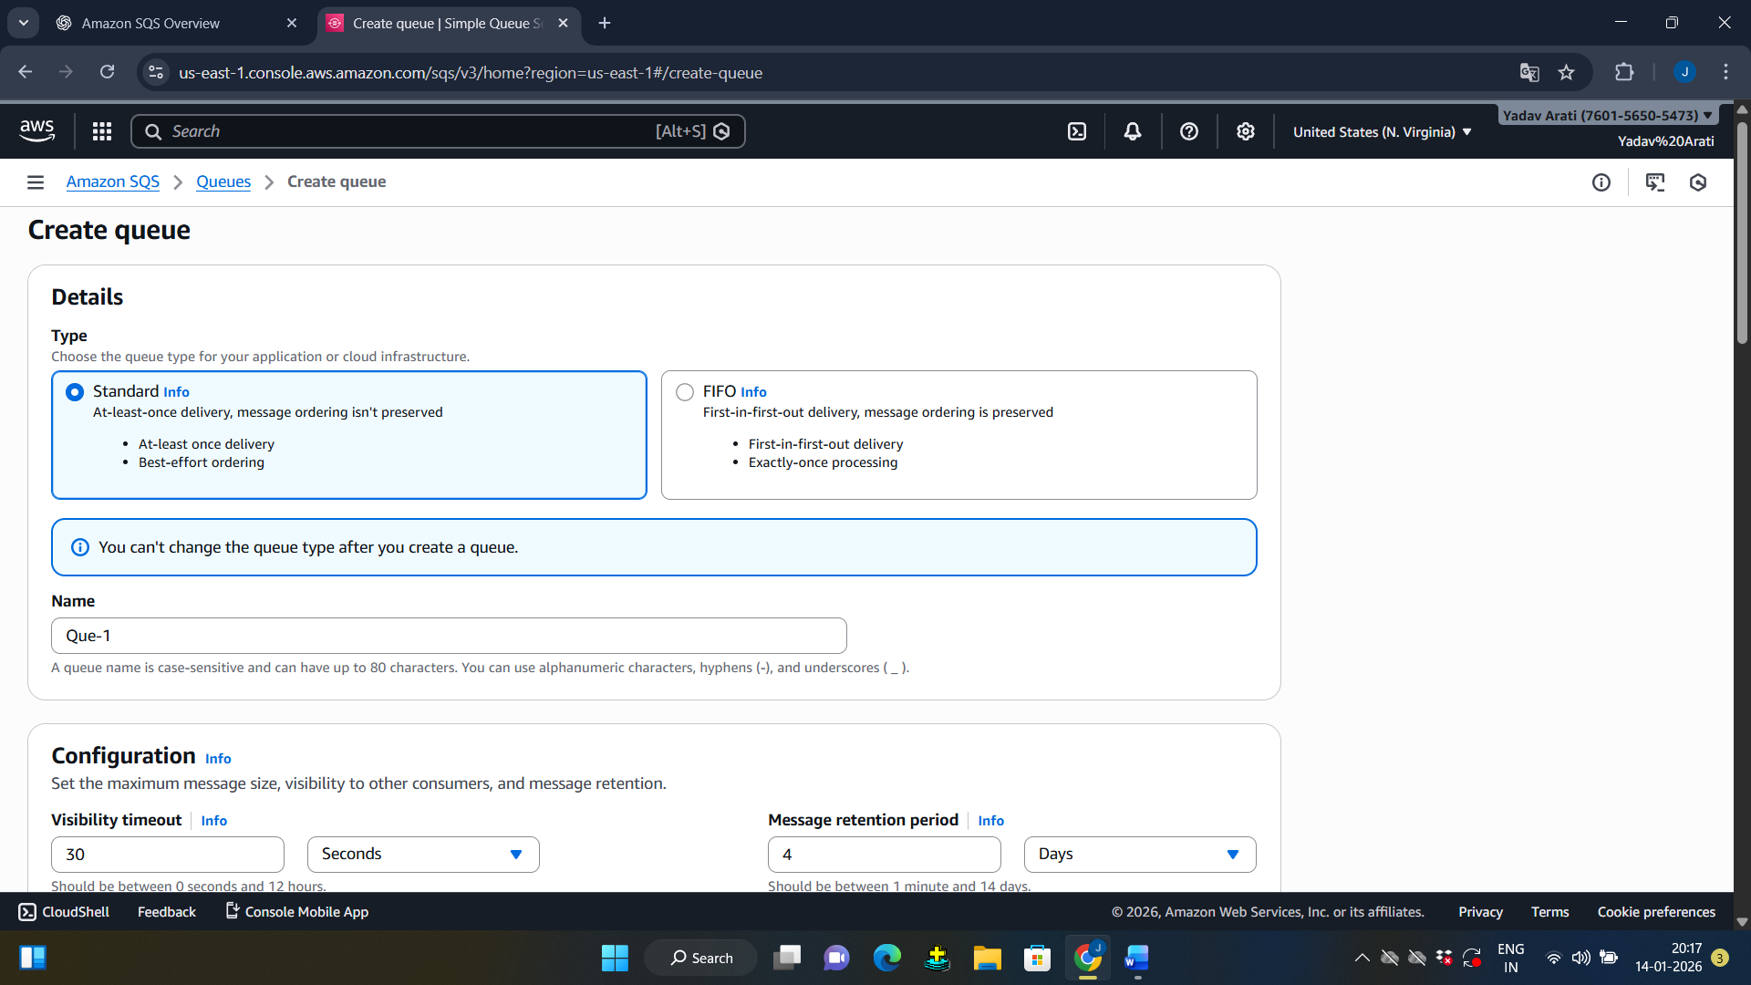

Queue is Created
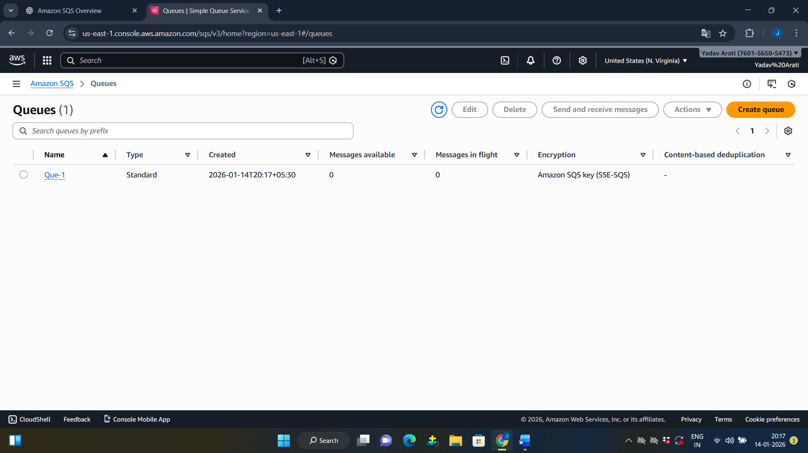
Step 5: Send a Message
- Open your queue
- Click Send and receive messages
- Type a message
- Click Send message

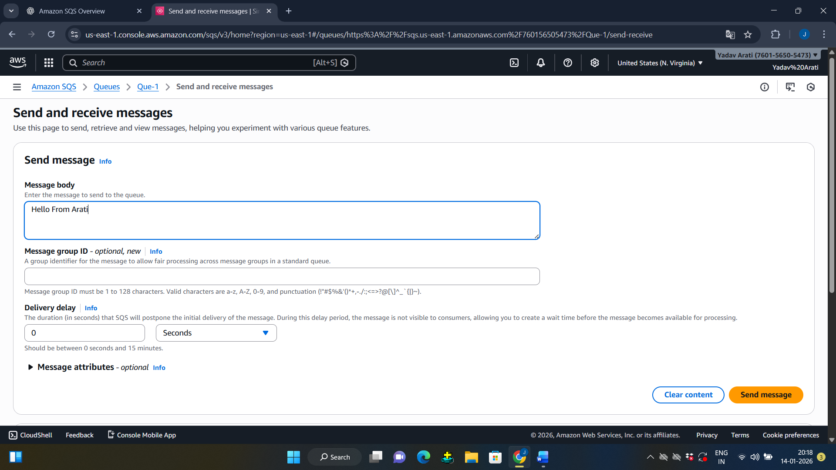

Step 6: Receive a Message
Click Poll for messages
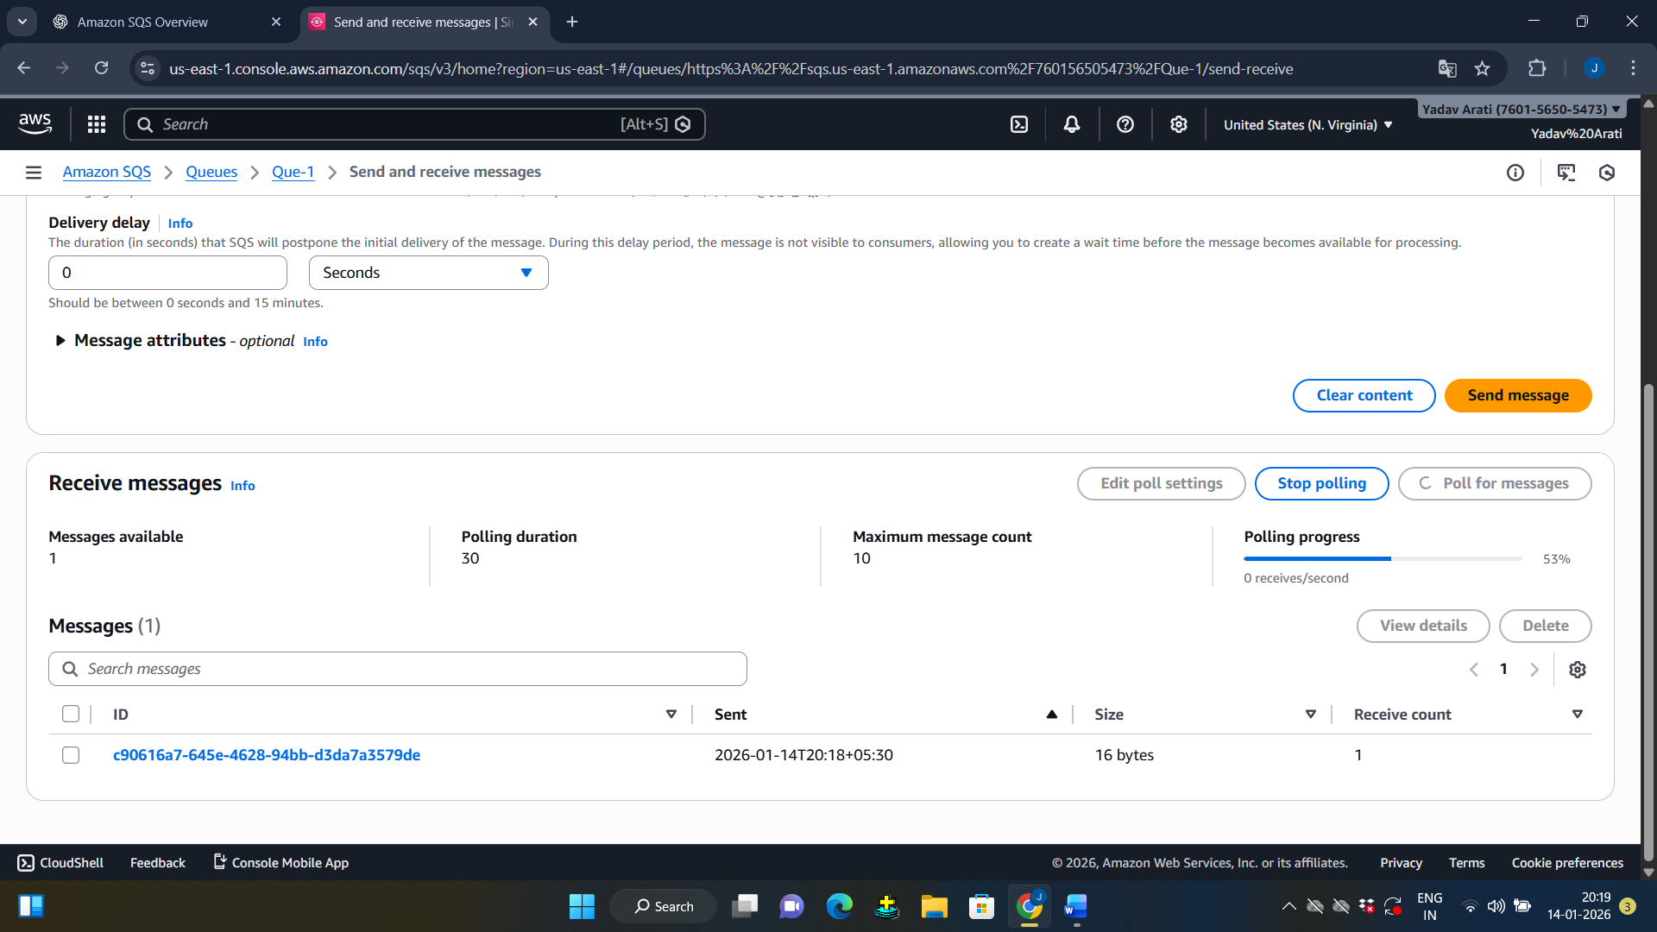
Message will appear
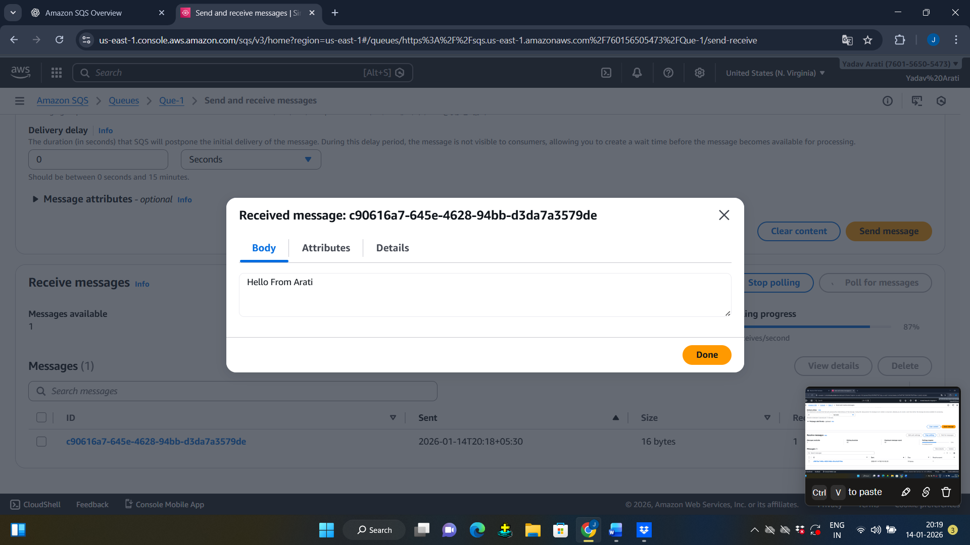
Summary :
Using AWS Console, you can create a queue, send messages, receive them, and process them easily

